How does Wales compare to other countries when it comes to recycling?

In a recent study it was revealed that Wales is one of the countries that recycle most, with a recycling rate of 52.2% in 2018. In 2010 the Welsh Government set out a plan to be able to recycle 70% of the waste produced by 2025. But how does this compare with other countries across Europe?

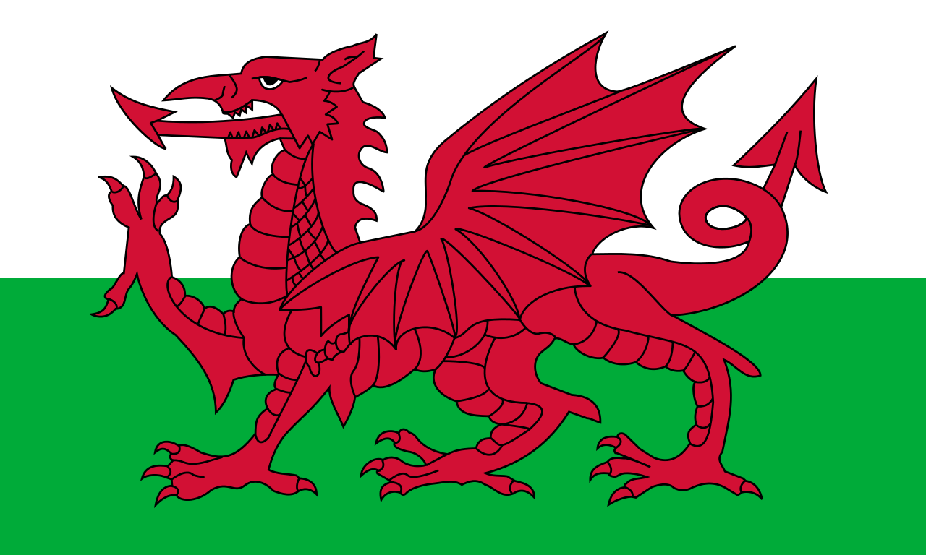

How Different Countries Recycle
Germany

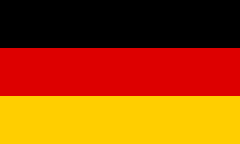
Since 2016, Germany has had the highest recycling rate in the world, with 56.1% of all waste it produced last year being recycled. In 1990, Germany looked at how companies packaged items to help reduce the potential rise of landfill problems. To help prevent this, the German government made companies responsible for the packaging waste they developed.
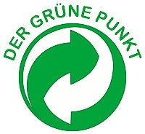
The companies created ‘The Green Dot’ that collected waste from households and businesses. This has meant that the percentage of waste that gets recycled in Germany has raised from 3% in 1990, to 56.1% today.
In 2019, Germany passed an act to reduce the impact of packaging waste on the environment, as well as making companies more responsible for using eco-friendly products.
To find out more about recycling in Germany, here are some links:
https://ukgermanconnection.org/kids/find-out-en/bottle-recycling-machines/
How Different Countries Recycle
Hungary


In Hungary, an estimated 100 million tonnes of rubbish is produced every year, 20% of which comes from households. While 80-90% of Hungarians claim that they recycle, the numbers show that 15% of the people actually do so according to a 2016 report.
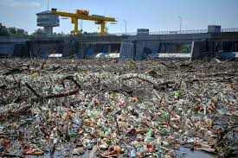
In a 2018 report, Hungary and 14 other countries were warned that they risked falling behind on their waste recycling target. According to the Hungarian Government the average Hungarian uses 80 plastic bags every year, and most of these bags end up in landfill, where they release harmful gases. In Hungary, 35% of the waste produced is recycled, but 51% of the waste produced goes to landfill sites.
To reduce the amount of waste that goes to landfill, the Hungarian Government have decided to ban single-use plastics in 2021. In 2015, to reduce e-waste (technology waste such as old devices and appliances) the Government decided that people would receive discounts when buying new appliances, when the old appliance is removed.
How Different Countries Recycle
Turkey

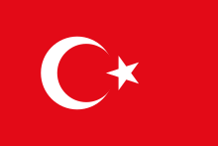
Last year, Turkey accepted 11.4 million tonnes of waste from countries across Europe, including 600,000 tonnes of plastic. According to a 2020 report, Turkey was ranked as one of the worst countries in terms of recycling waste worldwide. In 2018 only 12% of Turkey’s waste was recycled.
To deal with the amount of waste that is sent to the country, according to Interpol, companies often start illegal fires to burn plastic at landfill sites. This means harmful gasses are released to the environment.
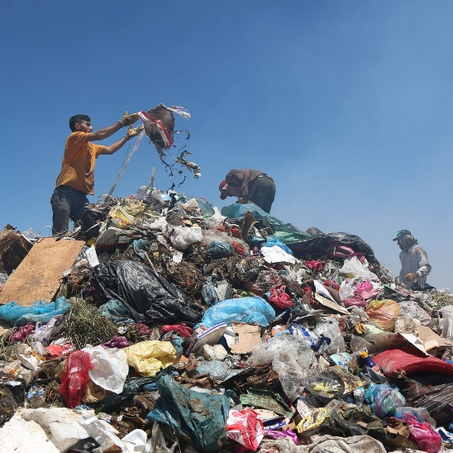
In 2017, Turkey’s first lady, Emine Erdoğan started the Zero Waste Campaign. This campaign would try to boost recycling in Turkey to 35% by 2023. They also would put a fee on single use plastic such as plastic bags, and reduce the amount of imported waste from Europe by 50%. Until that happens, Turkey is stuck with a big waste problem.

